**Crestron Certified Integrated Partner Module: Controller Divider v2.0**

**Models:** Symetrix Integrator Series; 722, 760, 761, 780, 788. Jupiter Series; J4, J8, J12. SymNet; 8x8 DSP, Express Cobra DSP, Solus DSP, Edge DSP, Radius DSP.

**Device Type:** Audio Mixer, DSP.

**General Information**

The Certified Crestron Module SymNet Controller Divider is used to divide a single SymNet controller number's values into a user determined number of divisions. In the SymNet DSP this functionality is useful when triggering input, or output Selectors, as well as other control switches with multiple triggers. Essentially, this module is used to control any SymNet Controller Number which can have more than two values. It is a SIMPL+ module which must be compiled in the User+ directory and brought into your SIMPL Program.

**Category:** Mixer, Audio DSP.

**Version:** 2.0

**Summary:**

The SymNet Controller Divider Crestron Module is a SIMPL + module which communicateswith a single SymNet Controller Number and Divides its value of 65,535 into a specifiednumber of divisions.

**General Notes:**

Input Selectors created in SymNet Composer are "Custom", meaning that the integrator can choose how large or small the selection index will be. If a 4 input, or 5 input, or 17 input selector is desired, the integrator can put this number into the SymNet Composer dialogue after dragging the custom input selector into the Composer configuration view. An input selector with that number of inputs will appear. In order to accommodate this scheme with Crestron control it is necessary to have a SymNet Controller Divider Crestron module that will allow the Integrator to choose a custom number of divisions for the SymNet Controller Value, which is from (0) to (65,535).

It is worth reading the SymNet Control Protocol document for the Series to which you wish to communicate with using this module. The SymNet Control Protocol is identical for each series. The factor to consider is whether the SymNet Controller Numbers have already been assigned; as in the case of Jupiter, and Integrator Series. With SymNet open architecture DSP you need to assign the SymNet Controller Numbers yourself. Open architecture DSP such as the 8x8 DSP, Express Cobra, Solus, Edge and Radius has open architecture and thus the SymNet Controller Numbers are assigned by the integrator at the time of design.

**Crestron Hardware Required:**

2 or 3 Series. RS-232, or UDP card required.

**Setup of Crestron Hardware:**

*RS-232.* Baud Rate; 38400 to 115200 - Configurable through SymNet Software Application. 8 Bit, Non-Parity, Stop Bit; 1, Flow Control; None.

*Crestron Cable Type.* CNSP-121

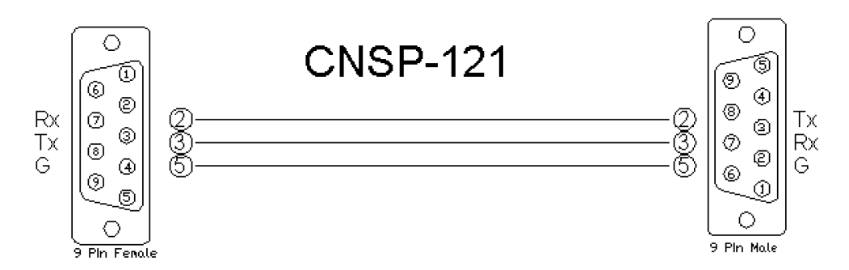

*UDP/IP.* Port: 48630.

**Application Notes:**

The number of divisions which are desired should be entered into the designated module field in the Crestron SIMPL Windows project.  Also, when configuring the Controller Divider module, the SymNet Controller Number which is assigned to the parameter you're interested in should be entered. Extra variable fields for the divisions will have to be added manually by the programmer. This can be done in SIMPL Windows using the ALT +, or ALT- command to create, or remove the desired number of lines. For instance, if there is a SymNet (4) input Controller that is due to be controlled, enter the SymNet Controller Number, the Number of Divisions (4), and then add the number of necessary lines for the touch-panel variables associated with the inputs. For Example; A SymNet (4) input selector will have (4) touch panel variables associated with the choices. We can assign the SymNet Controller Number #1 to the Selection Fader. Add (4) fields to the SIMPL + Controller Divider module. The first press will send the string CS 1 0. The Second press will send CS 1 11141. The Third press will send CS 1 33442. The fourth press will send CS 1 55704. Any value between 55704 and 65535 which is sent will select the fourth (4th) input.

**Module Graphic:**

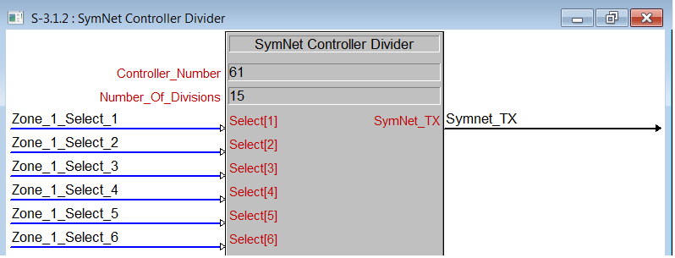

**Control:**

*Select [#].* Signal Type: Digital. Field for the placement of the selection touch-panel variables. If you have (4) inputs to select, hit Alt + to create (4) lines. Put the touch panel variable which represents the selection into these fields.

**Parameters:**

*Controller_Number.* Signal Type: Variable to be entered by the integrator. This is the SymNet Controller Number. Number_of_Divisions. Signal Type: Variable to be entered by the integrator. This variable is the number of input selections that are associated with the parameter. It is the number of times that 65,535 is going to be divided.

**Feedback:**

*SymNet_TX.* Signal Type: Serial. Serial signal to be routed to a 2-way serial COMport or UDP/IP symbol.

**Testing:**

*SymNet OS.* SymNet Designer v10.06, SymNet Composer v1.1, Jupiter Software v2.0.1.12, Integrator Series 761 Software v2.01. *SIMPL OS.* 4.01 *Crestron DB.* 35.00.004.00